# Experiment NO. 11

# Aim: To install HADOOP(Advance Topic)

# Theory :-

# What is Hadoop

Hadoop is an open source framework from Apache and is used to store process and analyze data which are very huge in volume. Hadoop is written in Java and is not OLAP (online analytical processing). It is used for batch/offline processing.It is being used by Facebook, Yahoo, Google, Twitter, LinkedIn and many more. Moreover it can be scaled up just by adding nodes in the cluster.

## Modules of Hadoop

1. **HDFS:** Hadoop Distributed File System. Google published its paper GFS and on the basis of that HDFS was developed. It states that the files will be broken into blocks and stored in nodes over the distributed architecture.
2. **Yarn:** Yet another Resource Negotiator is used for job scheduling and manage the cluster.
3. **Map Reduce:** This is a framework which helps Java programs to do the parallel computation on data using key value pair. The Map task takes input data and converts it into a data set which can be computed in Key value pair. The output of Map task is consumed by reduce task and then the out of reducer gives the desired result.
4. **Hadoop Common:** These Java libraries are used to start Hadoop and are used by other Hadoop modules.

## Hadoop Architecture

The Hadoop architecture is a package of the file system, MapReduce engine and the HDFS (Hadoop Distributed File System). The MapReduce engine can be MapReduce/MR1 or YARN/MR2.

A Hadoop cluster consists of a single master and multiple slave nodes. The master node includes Job Tracker, Task Tracker, NameNode, and DataNode whereas the slave node includes DataNode and TaskTracker.

## hadoop-architecture

## Advantages of Hadoop

* **Fast**
* **Scalable**
* **Cost Effective**
* **Resilient to failure**

**Introduction to R and r studio**

**R** is a programming language and software environment for statistical computing and graphics supported by the R Foundation for Statistical Computing. R is an integrated suite of software facilities for data manipulation, calculation and graphical display.

**RStudio** is an integrated development environment (IDE) for R. It includes a console, syntax-highlighting editor that supports direct code execution, as well as tools for plotting, history, debugging and workspace management.

### R Hadoop

The R Hadoop methods are the collection of packages. It contains three packages i.e., rmr, rhbase, and rhdfs.

**The rmr package**

For the Hadoop framework, the rmr package provides MapReduce functionality by executing the Mapping and Reducing codes in R.

**The rhbase package**

This package provides R database management capability with integration with HBASE.

**The rhdfs package**

This package provides file management capabilities by integrating with HDFS.

Installation of R, RStudio, and Packages for RHadoop

# Install R and RStudio

This section describes the installation process for R and RStudio on Ubuntu. To develop this guideline, I used installation codes on Cran R for Rbase from this [link.](https://cran.r-project.org/bin/linux/ubuntu/README.html) Also, I used the codes on Cran Rstudio for Rstudio Server from this [link.](https://www.rstudio.com/products/rstudio/download-server/)

To install the latest version of R package, CRAN repository should be added to the system.

You can replace the mirror address with an address from [this list](https://cran.r-project.org/mirrors.html) that is closer to your country.

Please make sure that you install R with your hduser (or any other user that you identified for Hadoop).

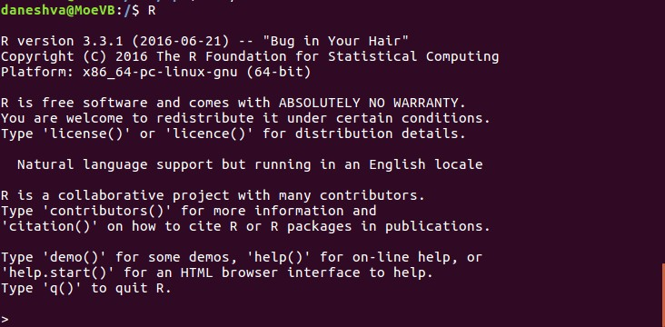

To create a better user interface for R, install RStudio Server. The perquisite for installation of RStudio Server is installation of R. To install RStudio Server, use the following commands (for 64 bits version). The commands required for installation of 32 bits version is presented in this [link.](https://www.rstudio.com/products/rstudio/download-server/)

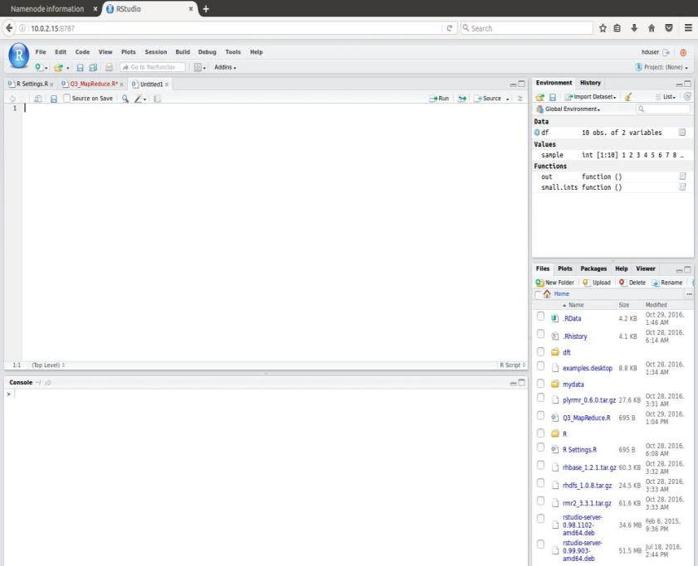

Fig 3. The interface of RStudio Server

You can write and execute any R script in both R and Rstudio Server

# Install Packages for RHadoop

RHadoop helps in an integrated interaction of R with Hadoop. RHadoop is a collection of R packages that enable R to use Hadoop data data management. These packages are:

* 1. plyrmr
  2. rmr
  3. rhdfs
  4. rhbase

The plyrmr package is a data processing tool. The MapReduce service is provided by rmr package. rhdfs enables working with the Hadoop file management system. Finally, rhbase is the means of database management.

Depending on the version of the packages, you might get error messages indicating that you need to install a specific package.

To run any program in RHadoop, one must ensure that appropriate user with enough permissions initiated the Hadoop (on terminal through commands stard-dfs.sh and start-yarn.sh).

Now, the RHadoop is ready to use.

Conclusion: Thus Hadoop is installed successfully.

VIVA QUESTIONS.

### 1) Explain big data and list its characteristics.

### 2).Explain Hadoop. List the core components of Hadoop

3) What is R-studio?

4) What is the need of R-studio?